DISCLAIMER
This manual template is intended to be used by the organisation and is a sample only. It does not negate any organisation from its OHS/ WHS duties within its state. The organisation must adhere to rules and regulations which accompany WHS for its industry also.

This document should be completed by the organisation in relation to the WHS / OHS regulations according to Safe Work Australia https://www.safeworkaustralia.gov.au/

Instructions
To be completed by organisation

Responsibilities
(Eg staff who are responsible for implementation of WHS)
WHO | RESPONSIBLE FOR

Risk management
This should show what risk management procedures have been undertaken for WHS

Training
This section should show what training will be undertaken

Review
This document should be reviewed annually to ensure all risks have been reviewed and mitigated.

Table 1 – Key Terms used in this document
Organisation to complete any further

Standards in relation to this document

Organisation to complete
STANDARD | WEBSITE
Organisation to complete any further

Reference documents & Websites which MUST be read in conjunction with this policy
Doc No | Reference / related Documents | Location
 | Organisation to complete |  | www.safework.gov.au

Policy

Introduction
This Manual is designed to allow blah blah blah

Legislation in relation to this policy
This should be updated according to the state the organisation is in and changed as necessary.
Work Health and Safety Act 2011 - https://www.legislation.nsw.gov.au/#/view/act/2011/10/part8/div1
Work Health and Safety Regulation 2017- https://www.legislation.nsw.gov.au/#/view/regulation/2017h/404/whole
Environmental Planning and Assessment Act- https://www.legislation.nsw.gov.au/#/view/act/2017/60

Scope
This policy and plan apply to all personnel working with name of organisation

Purpose
The objectives of this policy are to, as far as reasonably practicable:
• achieve a safe and incident free workplace
• consider WHS in (workplace)
• involve workers and subcontractors in the decision-making process through regular communication and consultation
• ensure workers and subcontractors identify and control risks in the workplace
• monitor and review the elimination or control of potential risks
• enhance workers’ WHS knowledge through a program of education and training.

Success of WHS
The success of our WHS management depends on:
• the commitment of all persons to achieve the policy objectives
• planning work activities, with due consideration given to WHS
• undertaking the risk management process in an effective manner
• communication and consultation between our workers and subcontractors.
To comply with this policy and plan, the Company expects all persons and organisations concerned to be fully committed to achieving these policy objectives as follows:
- to create and maintain a safe, healthy and productive working environments,
- to create and maintain continuous improvement strategies to ensure cost-effective, systematic and proactive WHS management, and
- to ensure compliance with WHS Legislation, Regulations and associated legislation.

Policy Statement
This policy MUST be read in conjunction with all Work Regulations and Code (Safework Australia, sourced 2018) and documents listed previously (needs to be reviewed and updated)
4.1 To address work related safety, will ensure:
Organisation to complete any further
  - All personnel will ensure:
Organisation to complete any further
4.3 The emergency plan will include:
Organisation to complete any further
  - Emergency procedures must include:
Organisation to complete any further

  - PPE will include
Organisation to complete any further
  - Personnel to be provide and maintain a safe system of work including:
Organisation to complete any further
  - First Aid: (regulation 42)
Organisation to complete any further
  - Facilities and the work environment: (regulation 40-41)
Organisation to complete any further

Procedures

Workplace Health & Safety Management System (WHSMS) Procedures
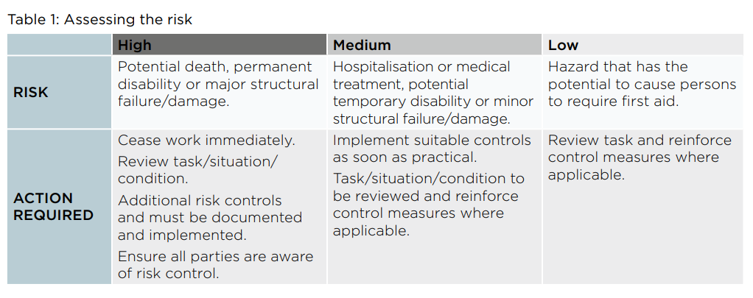
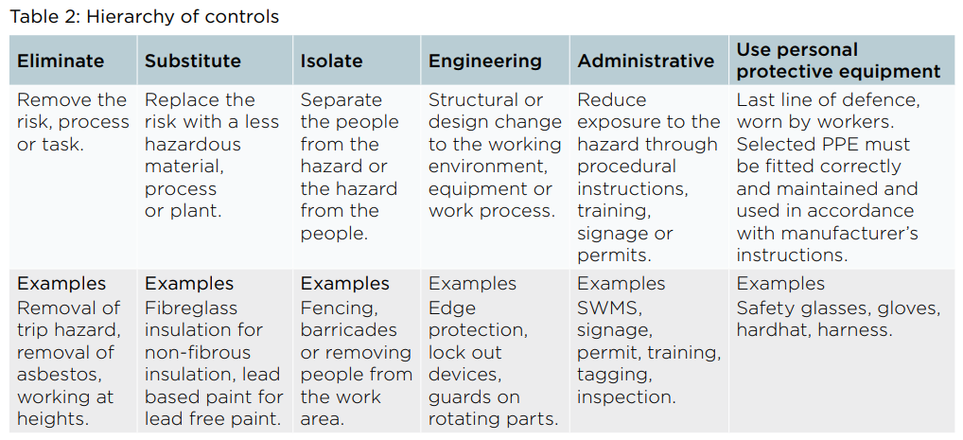
This section MUST be read in conjunction with the document Managing the work environment and facilities Code of Practice, available at https://www.safeworkaustralia.gov.au/system/files/documents/1809/code_of_practice_-_managing_the_work_environment_and_facilities.pdf

This diagram illustrates the various process associated with the development, implementation and maintenance of cost-effective and pro-active systems approach to implementing an effective Safety Management and Risk Management Program in order to demonstrate Due Diligence and to ensure the Duty of Care requirements of Legislation are met.

Duty of Care
Management Commitment
[Authorities, Responsibilities]
Risk Management
Identify Hazards
Assess the Risks
Control the Risks
Monitor Outcomes

Keep Records

Safety Management System

Safety Inspections
WHS Training

Injury Management
Injury register
Reduction of injuries and return to work at the earliest possible time
Performance Measurement
Internal reviews,
Onsite Audits

Process
Organisation to complete any further

Process- Risk Management
(regulation Sections 297, 32-38)
Read this section in conjunction with the Construction Work Code of Practice (Safework Australia, sourced 2018)
Organisation to complete any further

Process – WHS Management Plan
Read this section in conjunction with the Construction Work Code of Practice (Safework Australia, sourced 2018)
Organisation to complete any further

Process – Safety training
Organisation to complete any further

Process – WHS Training
Organisation to complete any further

Process-Emergency Planning
Read this section in conjunction with the Work Code of Practice
Organisation to complete any further

Process- PPE
Organisation to complete any further

Process-Facilities
Organisation to complete any further

COVID-19 Strategy
A separate policy should be written to support staff during COVID-19 Pandemic.
Organisation to complete any further

Appendix-templates

- WHS Management Plan
- Onsite Personnel Training & WHS Register
- Incident Report Register
- Training Plan

WHSM Plan template - Manager to complete before commencement of contract
THE ORGANISATION | ABN | PHONE
Site Location |  | Project Manager

RESPONSIBILITIES
Health and Safety Officer
First Aid Officer

RISK MANAGEMENT PLAN | Completed/date | Key personnel required
Risk Management
Onsite list of workers

TRAINING
Induction training for all personnel? | Onsite training required

PAGE 2 WHS Management Plan
Noted /Attached? |  | Y/N
Work environment safety plan
Workplace security and public safety plan

EMERGENCY/INCIDENTS
Emergency Plan |  | Emergency procedures
Incident Plan |  | PPE needed (list)
Site Specific rules |  | First Aid Arrangements
Falling objects noted and assessed? |  | Provision and maintenance of a hazardous chemicals register, safety data sheets and hazardous chemicals storage
PAGE 3 WHS Management Plan

COMMUNICATIONS PLAN
WHO | HOW  Email/face to face/phone | FREQUENCY | PURPOSE

